Response Paper #1 — *War Photographer*

*Write at least one paragraph (3-5 sentences) per question. These will be graded for integration of knowledge, depth of discussion, cohesiveness, spelling & grammar, sources and citations (no APA style necessary). Although the questions are based on concepts and information from the film, online research is necessary to thoroughly and accurately answer the questions. Be sure to carefully read each question first, before answering.*

# 1. James Nachtwey is well known for his war photography, but he is also well regarded as a “concerned photographer.” He makes numerous thoughtful statements concerning humanity in published articles, interviews, documentaries and speeches. Chose a quote from Nachtwey and discuss its significance along with your personal opinion of the statement.

"For me, the strength of photography lies in its ability to evoke humanity. If war is an attempt to negate humanity, then photography can be perceived as the opposite of war."

*—from* [*https://www.azquotes.com/quote/715494*](https://www.azquotes.com/quote/715494)

I like this quote because it speaks to the importance of good journalism in times of crisis. In modern times, we have the physical means to resolve wars and help those who are suffering; the real obstacle to world peace is the human element. Through photography, journalists can capture some of the emotions of those living in the worst conditions and expose them to the outside world. Getting the populace to rally in support of an oppressed people is the first step towards fighting their oppression, and I think this quote eloquently states that in just a few words.

# 2. Nachtwey spends an immense amount of time explaining his motivations for becoming a photojournalist. Discuss at least one of these motives and explain how you think it impacts his photographic work.

One of Nachtwey's biggest motivations is to bear witness. In his 2007 TED talk, he stated, "I'm a witness, and I want my testimony to be honest and uncensored. I also want it to be powerful and eloquent, and to do as much justice as possible to the experience of the people I'm photographing." I think this principle shows through in his photography, as his images are often some of the most raw portrayals of the crises he covers. While some publications or photographers will hold back from showing particularly haunting images of tragedy to avoid upsetting their audience, Nachtwey puts himself in the middle of horrific scenes and doesn't hold back from showing the worst of it. At the end of the film, he comments on how he could be seen as benefiting from tragedy, asking, "Do I make a living from other people's suffering?" However, from his body of work, it's clear that he does not let this concern hold him back from bearing witness and telling the full unredacted story with his photos.

## Sources

* Nachtwey, James. "My wish: Let my photographs bear witness." (2007) *TED*. <https://www.ted.com/talks/james_nachtwey_my_wish_let_my_photographs_bear_witness/transcript>

# 3. Throughout the movie, Nachtwey asserts the concept that photojournalism gives a voice to those who otherwise would go unnoticed. Describe an example of this act shown in the documentary *War Photographer*. Do you agree with this statement? Why or why not?

A good example of Nachtwey giving a voice to the voiceless is when he documented a sulfur mine at a volcano in East Java, Indonesia. The mine air was thick with sulfur dust and Nachtwey went in with minimal protection. Very few people would be willing to enter such harsh conditions; even the documentary crew largely kept out of harm's way. Without photojournalists like Nachtwey documenting such awful conditions, it is likely we would never learn about the suffering of those mine workers.

## Sources

* McElvaney, Kevin. "The Men Who Mine Volcanoes." (2015) *The Atlantic.* <https://www.theatlantic.com/international/archive/2015/02/the-men-who-mine-volcanoes-indonesia/385913/>

# 4. The importance of Nachtwey's work has been discussed at length in many publications, lectures and forums. Research one of Nachtwey’s images and discuss the story behind its creation, including where, when, why and how it was made. Where was it originally published?

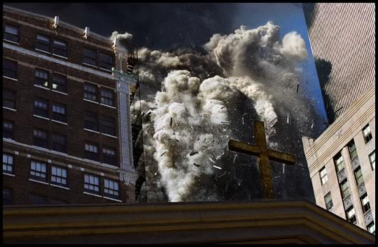

Nachtwey's photographs of the 9/11 attacks in New York City, including the iconic photo above, came to be largely by chance. He was usually busy out of the country documenting foreign conflicts, but he had just gotten home on a flight the night before and was staying in his apartment near Wall Street. When the planes struck on the morning of September 11th, he grabbed 28 rolls of film and ran towards the Twin Towers, which were just a relatively few blocks away. His photos were ultimately published by *Time*, including fourteen images which garnered two million views on Time.com (a staggering total by 2001 standards).

## Sources

* Strauss, David Levi. "Revisiting 9/11: Unpublished Photos by James Nachtwey." (2011) *Time*. <https://time.com/3528699/revisiting-911-unpublished-photos-by-james-nachtwey/>

# 5. Briefly research and discuss the group of war photographers known as the “Bang Bang Club,” including Nachtwey’s interaction with the quartet. Be sure to list the names of each photographer along with their whereabouts.

The Bang-Bang Club was a group of four photographers – Kevin Carter, Greg Marinovich, Ken Oosterbroek, and João Silva – who captured the violent transition from apartheid to democracy in South Africa in the 1990s. They worked with a number of other photographers such as Nachtwey, who said of them, "We were several photographers who felt a bond with each other and were able to work very well with each other. I think we all shared a sense of commitment to what was going on and I felt very privileged to be working with great South African photographers." (Robles) The photographers personally suffered greatly as a result of their work; Oosterbroek was killed during the conflict in 1993, Carter committed suicide just days after winning the Pulitzer Prize in 1994, and Silva later lost both his legs while working in Afghanistan in 2010.

## Sources

* "Joao Silva: ‘This Is What I Do. This Is All That I Know.’" (2011) *The New York Times.* <https://lens.blogs.nytimes.com/2011/08/30/this-is-what-i-do-this-is-all-that-i-know/>
* Keller, Bill. "Kevin Carter, a Pulitzer Winner For Sudan Photo, Is Dead at 33." (1994) *The New York Times.* <https://www.nytimes.com/1994/07/29/world/kevin-carter-a-pulitzer-winner-for-sudan-photo-is-dead-at-33.html>
* Robles, Anthony. "Q&A with photojournalist James Nachtwey '70." (2018) *The Dartmouth.* <https://www.thedartmouth.com/article/2018/09/q-and-a-james-nachtwey>